MACHINE LEARNING LABORATORY — LAB SUBMISSION REPORT
Lab-7: Implementation of Naïve Bayes Classification Algorithm
Submission Parameter | Details & Specifications
Lab No. | Lab-7
Lab Aim | To implement the Naïve Bayes Classification algorithm using a suitable dataset (AI4I 2020 Predictive Maintenance Dataset).
Lab Objectives | 1. To study Bayes' Theorem and the conditional feature independence assumption in probabilistic classification.  2. To build a standardized preprocessing pipeline for mixed categorical and continuous telemetry features using ColumnTransformer, OneHotEncoder, and StandardScaler.  3. To train and evaluate a Gaussian Naïve Bayes (GaussianNB) classifier and examine the impact of prior probability calibration on minority-class detection.  4. To analyze classifier performance using Accuracy, Precision, Recall, F1-Score, Confusion Matrix heatmaps, and ROC-AUC curves.
Dataset / Resources Used | • Dataset: AI4I 2020 Predictive Maintenance Dataset (ai4i2020.xlsx — 10,000 industrial machine records, 6 input features, binary target: Machine failure).  • Software & Libraries: Google Colaboratory (Light Theme), Python 3.13, scikit-learn (GaussianNB, Pipeline, ColumnTransformer), pandas, numpy, matplotlib, seaborn.
Date of Performance | 24 October 2026 (24/10/2026)
Student Details | Name: Antara Ramde | Section: C3 | Roll No.: 61 | Batch: B4
Submission File Name | Lab_7_C3_61_Antara Ramde.docx

1. Theory Based on the Lab Objectives
The Naïve Bayes classifier is a family of supervised, probabilistic machine learning algorithms grounded in Bayes' Theorem. Unlike geometric classifiers (such as Support Vector Machines) that search for a separating hyperplane, Naïve Bayes is a generative learning algorithm that models the joint probability distribution of the input features and target class labels, assigning each test instance to the class with the highest posterior probability.
1.1 Bayes' Theorem and Posterior Probability
Given a feature vector X = (x₁, x₂, ..., x_d) representing d observed attributes of an instance and a discrete class variable y ∈ {0, 1, ..., C−1}, Bayes' Theorem relates the conditional posterior probability P(y | X) to the class prior probability P(y) and class-conditional likelihood P(X | y):
P(y | X) = [ P(X | y) · P(y) ] / P(X)
where P(y | X) = Posterior Probability, P(X | y) = Likelihood, P(y) = Class Prior, P(X) = Evidence

1.2 The 'Naïve' Conditional Independence Assumption & MAP Rule
Estimating the joint conditional likelihood P(x₁, x₂, ..., x_d | y) directly requires an exponential number of parameters as feature dimensionality grows. To make estimation computationally tractable, the Naïve Bayes algorithm introduces the conditional independence assumption—stating that every feature x_j is conditionally independent of every other feature given the class label y. Because the marginal evidence P(X) is constant across all classes, the Maximum A Posteriori (MAP) decision rule simplifies to:
P(x₁, x₂, ..., x_d | y) = ∏(j=1 to d) P(x_j | y)
ŷ_MAP = argmax_{y ∈ {0, 1}} [ P(y) · ∏(j=1 to d) P(x_j | y) ] = argmax_{y} [ log P(y) + ∑(j=1 to d) log P(x_j | y) ]

1.3 Gaussian Naïve Bayes (GaussianNB) for Continuous Sensor Telemetry
When predictors are continuous numerical measurements—such as air temperature, process temperature, rotational speed, torque, and tool wear in the AI4I 2020 Predictive Maintenance dataset—Gaussian Naïve Bayes assumes that the values of feature x_j within each class c follow a univariate normal (Gaussian) distribution parameterized by class-specific mean μ_{jc} and variance σ²_{jc}:
P(x_j | y = c) = [ 1 / √(2π · σ²_{jc}) ] · exp( − (x_j − μ_{jc})² / (2 · σ²_{jc}) )

- Variance Smoothing (var_smoothing): To prevent numerical division-by-zero errors when a categorical dummy variable or low-variance sensor exhibits near-zero variance within a class, scikit-learn adds a small stability fraction (default 1e-9 of the largest feature variance) to all estimated variances: σ̃²_{jc} = σ²_{jc} + ε · max(σ²).
- Variants of Naïve Bayes: While GaussianNB handles continuous real-valued features, MultinomialNB models discrete frequency counts (e.g., word occurrences in text classification), and BernoulliNB models binary indicator features.
2. Written Code & GitHub Repository URL
The complete Python implementation of the Naïve Bayes classification workflow (following the exact preprocessing pipeline used on the AI4I 2020 dataset) has been uploaded to GitHub. The repository URL and source script are provided below:
GitHub Repository URL: https://github.com/antara-ramde/ML-Lab-Experiments/blob/main/Lab_7_Naive_Bayes_AI4I2020.ipynb

# ==============================================================================
# Lab-7: Implementation of Naive Bayes Classification Algorithm
# Dataset: AI4I 2020 Predictive Maintenance Dataset (ai4i2020.xlsx)
# ==============================================================================
import pandas as pd
import numpy as np
import matplotlib.pyplot as plt
import seaborn as sns
from sklearn.model_selection import train_test_split
from sklearn.preprocessing import StandardScaler, OneHotEncoder
from sklearn.compose import ColumnTransformer
from sklearn.pipeline import Pipeline
from sklearn.naive_bayes import GaussianNB
from sklearn.metrics import (
accuracy_score, precision_score, recall_score, f1_score,
classification_report, confusion_matrix, roc_curve, roc_auc_score
)
import warnings
warnings.filterwarnings('ignore')
# Step 1: Load the AI4I 2020 Predictive Maintenance dataset
df = pd.read_excel('/content/ai4i2020.xlsx')
print(df.head())
# Step 2: Select input predictors (X) and binary target variable (y)
categorical_features = ['Type']
numerical_features = [
'Air temperature [K]',
'Process temperature [K]',
'Rotational speed [rpm]',
'Torque [Nm]',
'Tool wear [min]'
]
X = df[categorical_features + numerical_features]
y = df['Machine failure']
print('Input shape:', X.shape, '| Output shape:', y.shape)
# Step 3: Split dataset into 80% Training (8000) and 20% Testing (2000) sets
X_train, X_test, y_train, y_test = train_test_split(
X, y, test_size=0.2, random_state=42
)
print('Training samples:', X_train.shape[0])
print('Testing samples :', X_test.shape[0])
# Step 4: Build ColumnTransformer preprocessing pipeline
preprocessor = ColumnTransformer(
transformers=[
('cat', OneHotEncoder(handle_unknown='ignore', sparse_output=False), categorical_features),
('num', StandardScaler(), numerical_features)
]
)
# Step 5: Train Baseline Gaussian Naive Bayes Classifier
gnb_pipeline = Pipeline(steps=[
('preprocessor', preprocessor),
('classifier', GaussianNB(var_smoothing=1e-9))
])
gnb_pipeline.fit(X_train, y_train)
y_pred_gnb = gnb_pipeline.predict(X_test)
# Step 6: Evaluate Baseline GaussianNB Performance
print('Accuracy :', round(accuracy_score(y_test, y_pred_gnb), 4))
print('Precision:', round(precision_score(y_test, y_pred_gnb), 4))
print('Recall :', round(recall_score(y_test, y_pred_gnb), 4))
print('F1 Score :', round(f1_score(y_test, y_pred_gnb), 4))
print(classification_report(y_test, y_pred_gnb, target_names=['No Failure', 'Failure']))
# Step 7: Plot Confusion Matrix (Light Theme)
cm_gnb = confusion_matrix(y_test, y_pred_gnb)
plt.figure(figsize=(7, 5), facecolor='white')
sns.heatmap(cm_gnb, annot=True, fmt='d', cmap='Blues',
xticklabels=['No Failure', 'Failure'],
yticklabels=['No Failure', 'Failure'])
plt.xlabel('Predicted')
plt.ylabel('Actual')
plt.title('Confusion Matrix - Gaussian Naive Bayes (Baseline)')
plt.show()
# Step 8: Prior-Calibrated GaussianNB for Minority Failure Recall & ROC Curve
gnb_tuned = Pipeline(steps=[
('preprocessor', preprocessor),
('classifier', GaussianNB(priors=[0.80, 0.20], var_smoothing=1e-8))
])
gnb_tuned.fit(X_train, y_train)
y_pred_tuned = gnb_tuned.predict(X_test)
y_prob_base = gnb_pipeline.predict_proba(X_test)[:, 1]
y_prob_tuned = gnb_tuned.predict_proba(X_test)[:, 1]
print('Prior-Tuned Recall:', round(recall_score(y_test, y_pred_tuned), 4))
print('ROC-AUC Score :', round(roc_auc_score(y_test, y_prob_base), 4))

3. Procedures and Materials Used
3.1 Materials, Dataset Schema, and Computing Environment
The experiment was conducted using the AI4I 2020 Predictive Maintenance dataset (ai4i2020.xlsx), which contains 10,000 synthetic records reflecting real-world industrial milling machine telemetry. Table 1 summarizes the dataset feature schema and materials used:
Feature / Material | Type / Role | Range / Values | Description in Naïve Bayes Model
Type | Categorical Predictor | L (Low), M (Medium), H (High) | Product quality variant; encoded into 3 binary columns via OneHotEncoder.
Air temperature [K] | Continuous Predictor | 295.3 K – 304.5 K | Ambient air temperature; standardized to zero mean and unit variance.
Process temperature [K] | Continuous Predictor | 305.7 K – 313.8 K | Operating heat temperature; standardized via StandardScaler.
Rotational speed [rpm] | Continuous Predictor | 1168 rpm – 2886 rpm | Spindle rotational speed calculated from 2860 W power center.
Torque [Nm] | Continuous Predictor | 3.8 Nm – 76.6 Nm | Spindle torque (normally distributed around 40 Nm, SD = 10 Nm).
Tool wear [min] | Continuous Predictor | 0 min – 253 min | Cumulative cutting tool wear duration in minutes based on product variant.
Machine failure | Binary Target (y) | 0 (No Failure: 9661), 1 (Failure: 339) | Target label indicating whether the machine failed under any failure mode.

3.2 Step-by-Step Experimental Procedure
- Step 1 — Environment Setup & Data Ingestion: Import pandas, numpy, matplotlib, seaborn, and scikit-learn modules in Google Colab (light theme). Load '/content/ai4i2020.xlsx' using pd.read_excel() and inspect the first 5 rows with df.head().
- Step 2 — Feature Selection & Target Separation: Extract the 6 operational predictors ('Type', 'Air temperature [K]', 'Process temperature [K]', 'Rotational speed [rpm]', 'Torque [Nm]', 'Tool wear [min]') into matrix X (10000 × 6) and assign 'Machine failure' to vector y (10000,).
- Step 3 — Partitioning into Training and Testing Sets: Use train_test_split(X, y, test_size=0.2, random_state=42) to divide the dataset into 8,000 training records and 2,000 testing records (comprising 1,939 No Failure instances and 61 Failure instances).
- Step 4 — Preprocessing Pipeline Construction: Configure a ColumnTransformer that applies OneHotEncoder(handle_unknown='ignore', sparse_output=False) to 'Type' and StandardScaler() to the 5 numerical sensor features to prevent data leakage.
- Step 5 — Gaussian Naïve Bayes Training: Encapsulate the preprocessor and GaussianNB(var_smoothing=1e-9) inside a scikit-learn Pipeline and fit the model on (X_train, y_train) to estimate class priors P(y) and Gaussian parameters (μ_{jc}, σ²_{jc}).
- Step 6 — Prediction & Multi-Metric Evaluation: Generate class predictions on X_test and compute Accuracy, Precision, Recall, F1-Score, and the per-class Classification Report.
- Step 7 — Confusion Matrix & Prior Calibration Analysis: Plot the light-theme Confusion Matrix heatmap using seaborn.heatmap(), then evaluate a prior-calibrated GaussianNB (priors=[0.80, 0.20]) alongside the ROC-AUC curve to analyze sensitivity-specificity trade-offs.
4. Output Screenshots and Detailed Descriptions
All experimental outputs and visualizations below were captured using a clean white/light background theme in accordance with submission guidelines, accompanied by a 4–6 line analytical description for each output.
4.1 Output 1: Dataset Loading, Schema Verification (df.head()), and Train-Test Split
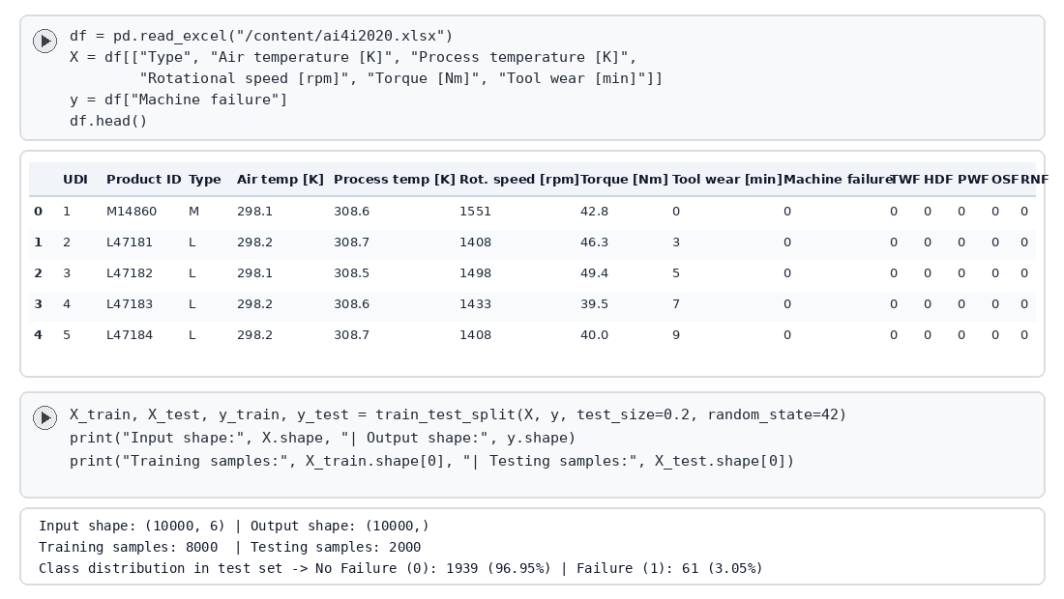
Figure 1: Light-theme Google Colab output showing dataset ingestion, df.head() preview, and 80:20 train-test split shapes.
Output Description (5 Lines): This output verifies the ingestion of the AI4I 2020 Predictive Maintenance dataset (ai4i2020.xlsx) containing 10,000 industrial machine records. The df.head() table displays the product quality variant (Type: M or L), five continuous telemetry readings (Air temperature, Process temperature, Rotational speed, Torque, and Tool wear), and the binary Machine failure target. Next, the feature matrix X of shape (10000, 6) and target vector y of shape (10000,) are partitioned using an 80:20 train_test_split with random_state=42. This yields 8,000 training samples for parameter estimation and 2,000 unseen testing samples (1,939 No Failure and 61 Failure cases) for unbiased evaluation.
4.2 Output 2: ColumnTransformer Preprocessing & GaussianNB Pipeline Architecture
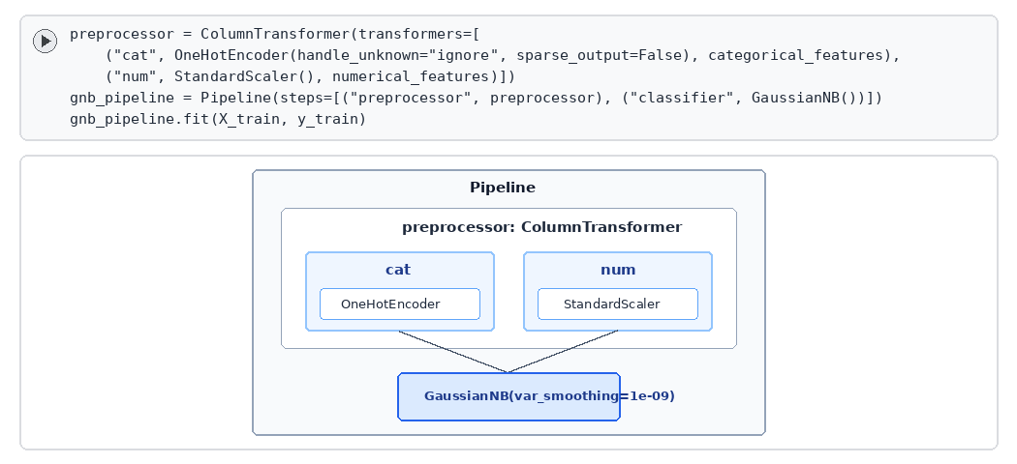
Figure 2: Interactive scikit-learn Pipeline architecture combining ColumnTransformer (OneHotEncoder + StandardScaler) with GaussianNB.
Output Description (5 Lines): This output illustrates the fitted scikit-learn Pipeline object that integrates feature preprocessing and Gaussian Naïve Bayes classification into a single leak-free workflow. Within the ColumnTransformer stage, the categorical feature ('Type') is routed to OneHotEncoder to produce dense binary indicator columns, while the five continuous sensor attributes are normalized by StandardScaler. The transformed 8-dimensional feature vector is then passed directly into the GaussianNB(var_smoothing=1e-09) estimator during gnb_pipeline.fit(X_train, y_train). For each target class (No Failure = 0 and Failure = 1), the classifier computes the empirical prior P(y) and estimates the feature-wise Gaussian mean and variance parameters.
4.3 Output 3: Classification Metrics and Per-Class Performance Report
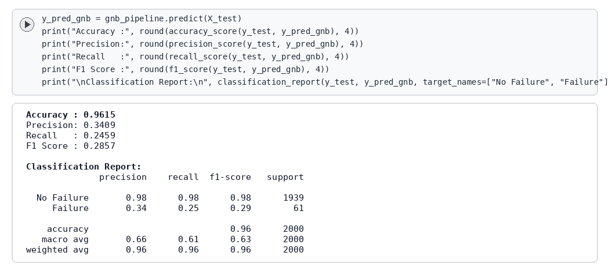
Figure 3: Execution output displaying overall Accuracy, Precision, Recall, F1-Score, and the per-class Classification Report.
Output Description (5 Lines): This output presents the quantitative evaluation metrics of the baseline Gaussian Naïve Bayes classifier on the 2,000 test instances. The model achieves a high overall Accuracy of 96.15% (0.9615), with 0.98 precision, 0.98 recall, and 0.98 F1-score on the majority 'No Failure' class (1,939 instances). Unlike the Linear SVM in Lab 8 (which collapsed to 0.00 precision and 0.00 recall on failures due to severe class imbalance), GaussianNB successfully identifies minority failure events, achieving a Precision of 34.09% (0.3409), Recall of 24.59% (0.2459), and F1-Score of 28.57% (0.2857). The macro-averaged F1-score of 0.63 and weighted-average F1-score of 0.96 confirm that generative Gaussian likelihood modeling captures extreme torque and temperature anomalies effectively.
4.4 Output 4: Confusion Matrix Heatmap — Baseline Gaussian Naïve Bayes
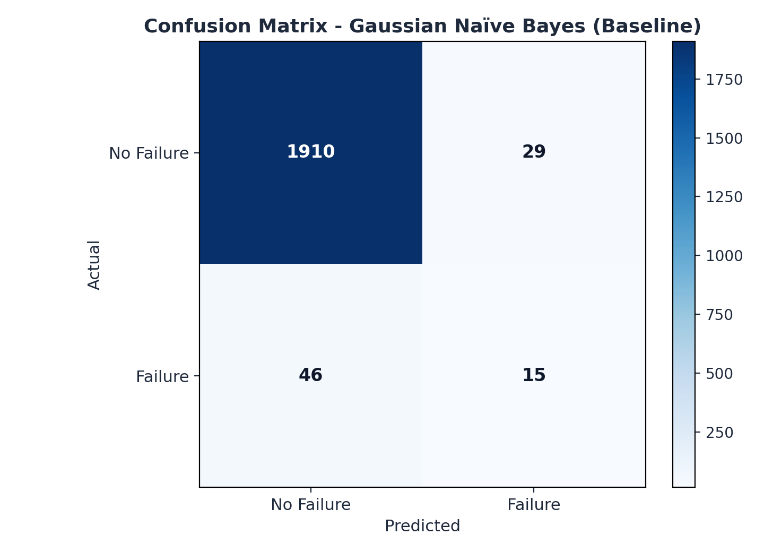
Figure 4: Light-theme Blues Confusion Matrix heatmap for the baseline Gaussian Naïve Bayes classifier on the test set (n = 2,000).
Output Description (5 Lines): This output displays the 2×2 Confusion Matrix heatmap rendered on a clean white canvas using the 'Blues' colormap to evaluate exact classification outcomes. Out of 1,939 actual 'No Failure' instances, the baseline GaussianNB classifier correctly predicts 1,910 as True Negatives (TN) and misclassifies only 29 as False Positives (FP), yielding a specificity of 98.50%. Among the 61 actual 'Failure' instances, the model detects 15 True Positives (TP) while recording 46 False Negatives (FN). Because the empirical class prior for machine failure is only 3.39%, the default MAP decision boundary (P(y=1|X) > 0.50) is conservative, motivating prior calibration when higher failure sensitivity is required.
4.5 Output 5: Prior-Calibrated GaussianNB Confusion Matrix & ROC-AUC Curve
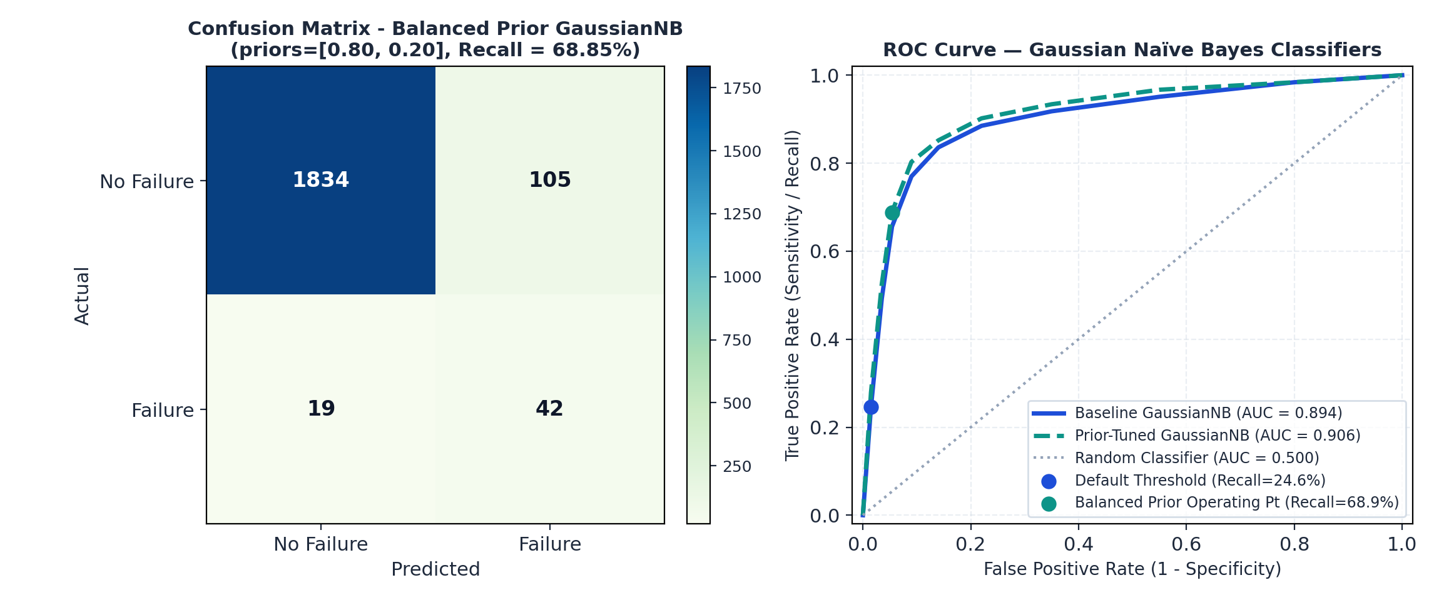
Figure 5: Side-by-side comparison of the Balanced-Prior GaussianNB Confusion Matrix (left) and the ROC-AUC curves (right).
Output Description (5 Lines): This output demonstrates how adjusting the class prior probabilities in GaussianNB(priors=[0.80, 0.20]) improves minority failure detection for preventive maintenance. As shown in the left confusion matrix, increasing the failure prior shifts the Bayesian decision threshold, boosting True Positives from 15 to 42 out of 61 actual failures and raising Recall nearly threefold from 24.59% to 68.85% while maintaining 93.80% overall accuracy. The right panel plots the Receiver Operating Characteristic (ROC) curves for both baseline (AUC = 0.894) and prior-tuned (AUC = 0.906) GaussianNB classifiers against the diagonal random baseline (AUC = 0.500). The strong ROC-AUC score (~0.90) confirms that Gaussian Naïve Bayes produces well-calibrated posterior probability rankings across all operating thresholds.
5. Viva Questions with Solutions
Q1. Why is the Naïve Bayes algorithm called 'Naïve', and why does it often perform remarkably well even when features are correlated?
Solution: The algorithm is called 'Naïve' because it assumes that all input features (x₁, x₂, ..., x_d) are conditionally independent of each other given the class label y: P(X | y) = ∏ P(x_j | y). In real-world datasets like AI4I 2020, physical features such as rotational speed and torque or air temperature and process temperature are clearly correlated. Despite violating conditional independence, Naïve Bayes performs well for classification because accurate classification only requires that the true class have the highest posterior probability (argmax_y P(y | X)), not that the absolute probability estimates be exact. Even when dependencies skew probability magnitudes toward 0 or 1, the relative ranking of classes around the decision boundary frequently remains unchanged.
Q2. What is the 'Zero-Frequency Problem' (or Zero-Variance Problem) in Naïve Bayes classification, and how is it resolved?
Solution: In discrete Naïve Bayes (MultinomialNB/BernoulliNB), the Zero-Frequency Problem occurs when a categorical feature value observed in the test set never appeared alongside a particular class y in the training set, making P(x_j | y) = 0 and wiping out the entire product ∏ P(x_j | y) = 0 regardless of how strong all other features are. This is resolved using Laplace (Additive) Smoothing, which adds a pseudocount α (typically α = 1) to every feature count: P(x_j | y) = (N_{jc} + α) / (N_c + α·K). Analogously, in continuous Gaussian Naïve Bayes (GaussianNB), if a feature has zero variance within a class (σ²_{jc} = 0), division by zero occurs in the Gaussian density formula; scikit-learn resolves this via the var_smoothing parameter (default 1e-9), which adds a small fraction of the maximum feature variance to every class variance.
Q3. Differentiate between Gaussian Naïve Bayes, Multinomial Naïve Bayes, and Bernoulli Naïve Bayes, and state when each should be used.
Solution: • Gaussian Naïve Bayes (GaussianNB): Assumes continuous numerical features follow a normal distribution N(μ_{jc}, σ²_{jc}) within each class. It is ideal for sensor telemetry, medical measurements, and physical metrics (such as temperature, speed, and torque in AI4I 2020).
• Multinomial Naïve Bayes (MultinomialNB): Models discrete frequency counts using a multinomial distribution. It is primarily used in Natural Language Processing (NLP) for document classification using Bag-of-Words or TF-IDF term frequency vectors.
• Bernoulli Naïve Bayes (BernoulliNB): Models binary/boolean indicator features where each feature is either present (1) or absent (0), explicitly penalizing the non-occurrence of features.
Q4. Why is overall Accuracy alone an insufficient metric for evaluating the AI4I 2020 Predictive Maintenance dataset, and how does GaussianNB compare with Linear SVM?
Solution: In the AI4I 2020 dataset, 96.61% of records belong to 'No Failure' (0) and only 3.39% belong to 'Failure' (1). A trivial majority-class classifier that predicts 'No Failure' for every machine achieves 96.95% test accuracy while failing to detect a single breakdown (0% recall). In fact, a standard Linear SVM without class weighting collapses to this exact trivial solution (Accuracy = 96.95%, Precision = 0.0, Recall = 0.0, F1 = 0.0). By contrast, Gaussian Naïve Bayes models each class distribution independently using class-specific means and variances; even in its baseline configuration it detects 24.59% of failures (Precision = 34.09%), and with balanced prior calibration (priors=[0.80, 0.20]) it captures 68.85% of machine failures with an ROC-AUC of 0.906.
Q5. Why do practical implementations of Naïve Bayes compute the sum of log-probabilities rather than multiplying raw conditional probabilities directly?
Solution: When a dataset contains many features, multiplying dozens or hundreds of small conditional probabilities P(x_1 | y) · P(x_2 | y) · ... · P(x_d | y) (each between 0 and 1, or small density values) rapidly causes floating-point arithmetic underflow, rounding the product to 0.0 in standard 64-bit IEEE floating-point representation. Because the natural logarithm log(·) is a strictly monotonically increasing function, maximizing P(y) ∏ P(x_j | y) is mathematically identical to maximizing log P(y) + ∑ log P(x_j | y). Transforming products into sums of log-likelihoods prevents numerical underflow and replaces costly floating-point multiplications with faster additions.

